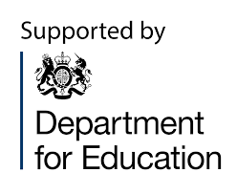
Survey
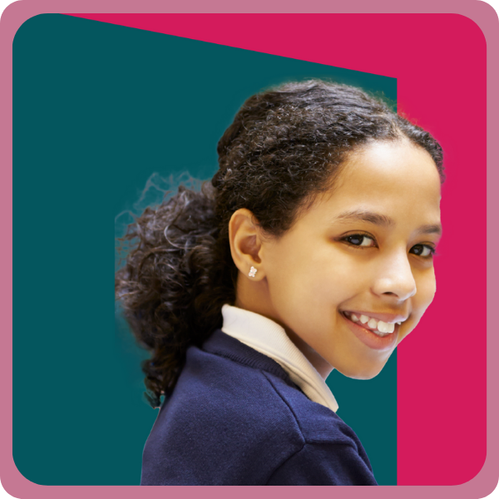
Tell us what you think about education and what needs to change

Reply by 22 November 2024.
This survey is in Easy Read.
Contents
Main points 2
Who this survey is for 2
About this survey 3
How to do this survey 4
Part 1. About you 5
Part 2. Primary education – ages 5 to 11 6
Part 3. Secondary education – ages 11 to 16 12
Part 4. College and 16 to 19 education 26
Part 5. Anything else? 27
Hard words and what they mean 29

Main points
We are a group of education experts who help the Government to make education better for children and young people in England.
We want to find out what you think about education for 5 to
19-year-olds.

Who this survey is for
This is for:
- people who use Easy Read
- anyone interested in education for children and young people
This is the Easy Read booklet of the Curriculum and Assessment Review.

About this survey

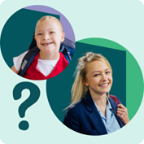

We want to know what you think about education for 5 to 19-year-olds.

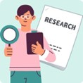
We are a group of experts who help the government make education better for children and young people in England.

This survey is a chance for us as a country
to make education better.

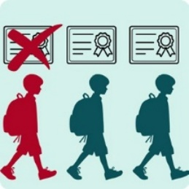
All children and young people should get
a good education. But 1 in 3 young people leave school at 16 with low grades.

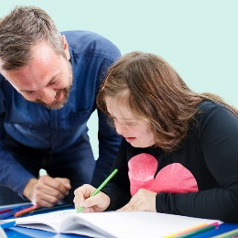
We know that many of these learners

- have disabilities
- speak a different language at home
- are from homes finding it hard to pay bills
- or need support for another reason

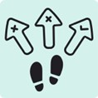
These learners have less chance of doing well in life because there are no clear choices for them to work or study at the age of 16.


In this survey, we want to find out what works well in education and what does not work well. And how we can do better.

How to do this survey

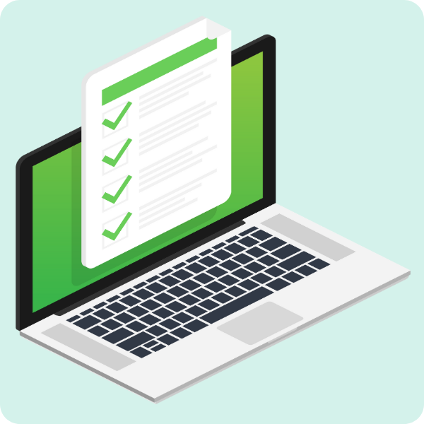
- Answer the questions in this survey.

- There are lots of questions, so you might want to have a break in between some
of them.

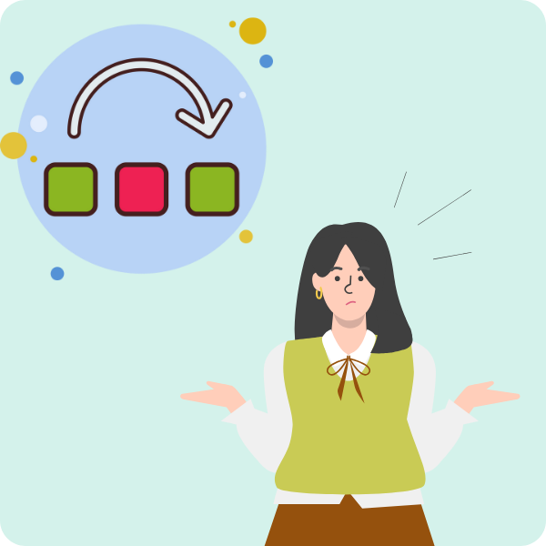

- You can leave any questions you cannot answer. For example, if you have nothing to say about secondary school, you can miss that out.

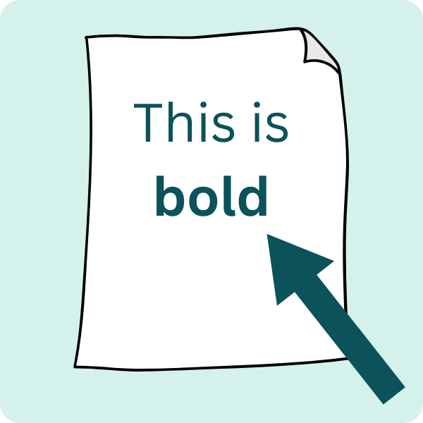

- We tell you what any words in bold mean at the back, on page 29.


- Send your survey back to us by email: coordinator.consultations@education.gov.uk

We need your survey by 22 November 2024.

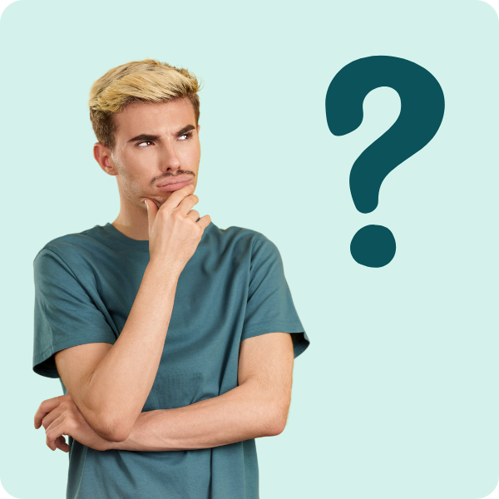

If you want to speak to us or have a question, please call 0370 000 2288.

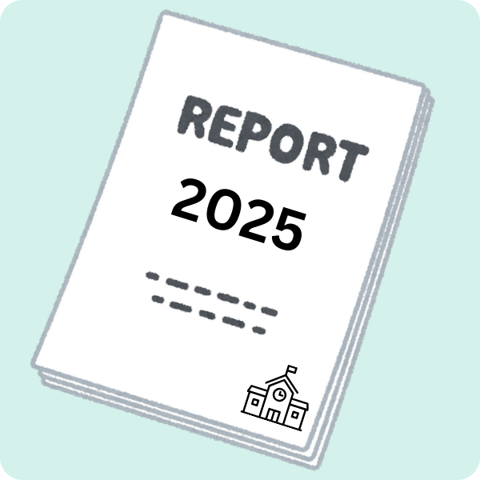
You can also do this survey online. Teachers and other professionals should use the online survey.

Part 1. About you

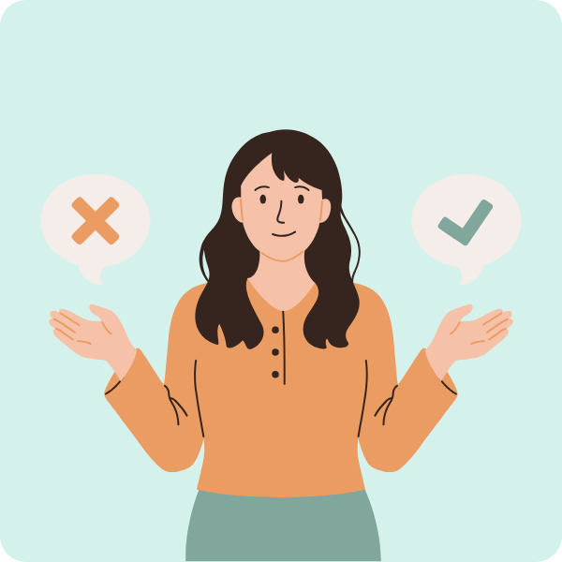
You do not have to answer these questions.
But your answers will really help us.

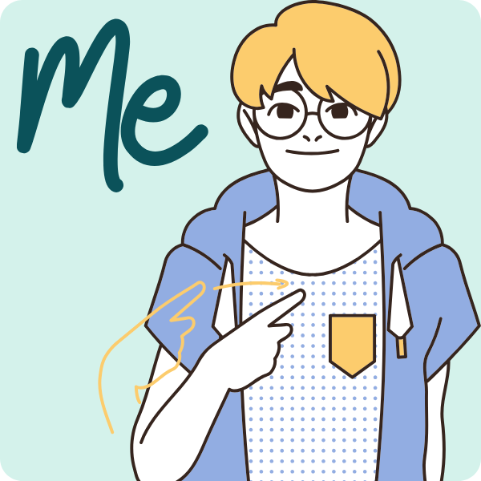
- What is your full name?

Click or tap here to enter text.

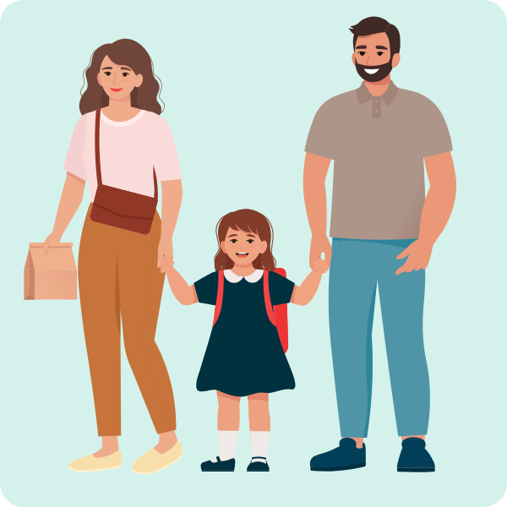
- Are you
a pupil, learner or student? ☐
a parent or carer? ☐
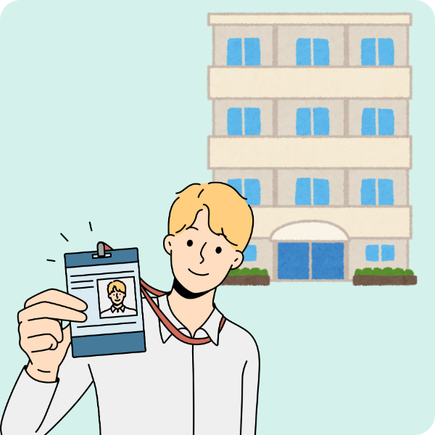
other? Please tell us below. ☐
Click or tap here to enter text.

If you are filling this in for an organisation, please tell us its name and what you do there.

- Can we contact you about your answers?

No. You can still do this survey. ☐

Yes. ☐
If yes, please give us your email address.
We will not share it with others.
Click or tap here to enter text.

Part 2. Primary education – ages 5 to 11

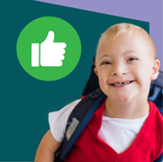
- What works well in primary school?

Tell us what you think about:
- what pupils learn
- how pupils are tested

Click or tap here to enter text.


- What does not work well in primary school?

Tell us what you think about:
- what pupils learn
- how pupils are tested

Click or tap here to enter text.

Part 2. Primary education – ages 5 to 11

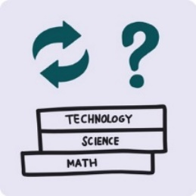
- Think about what schools teach and how they test pupils.
Is there anything that schools do that makes it harder for pupils who need
extra help?

Like pupils
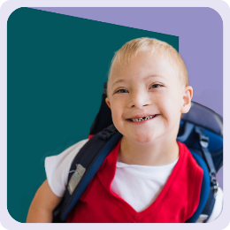
- with disabilities
- who speak a different language
at home
- from homes that find it harder to
pay bills and buy food

What can schools do to help these pupils?
Click or tap here to enter text.

Part 2. Primary education – ages 5 to 11

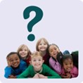
- Think about what schools teach and how they test pupils.
Is there anything that schools do that makes it harder for pupils with differences?
Like pupils who have different bodies, religions, ages, skin colour and family lives.
The law calls these protected characteristics.

Click or tap here to enter text.

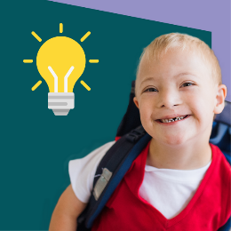

- What can schools do to help these pupils?

Click or tap here to enter text.

Part 2. Primary education – ages 5 to 11

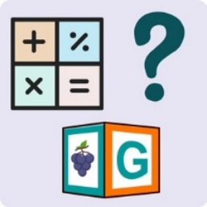
- How well do schools teach English and maths?
How can schools do this better?

Click or tap here to enter text.

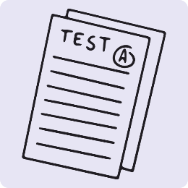
- Most children do English and maths tests like phonics, times tables and SATs.
Do you think tests make a difference to pupils’ health?
Are there better ways to test pupils?

Click or tap here to enter text.

Part 2. Primary education – ages 5 to 11

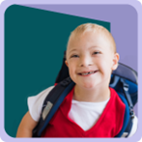
- Do you think schools teach enough arts, music and drama?
Are there better ways to teach these?

Click or tap here to enter text.

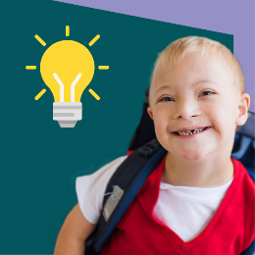
- Think about what schools teach and how they test pupils.
How can schools do more to help pupils aged 7 to 11 to learn?
This is in Year 3 to Year 6.

Click or tap here to enter text.

Part 2. Primary education – ages 5 to 11

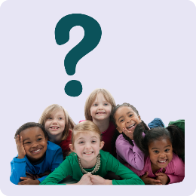
- How much do schools help pupils learn about diversity and people who are different from them?
Do schools teach pupils to be kind and respect other pupils?
Are there better ways to do this?

Click or tap here to enter text.

- How much do schools help pupils get the skills they need for life and to carry on learning at secondary school?
How can schools do this better?

Click or tap here to enter text.

Part 3. Secondary education – ages 11 to 16

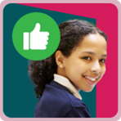
- What works well in secondary education?

Tell us what you think about:
- what pupils learn
- how pupils are tested
- how pupils can study towards certificates

Certificates show that a pupil has passed a test and now have a qualification.

Click or tap here to enter text.

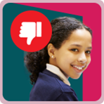
- What does not work well in secondary education?

Tell us what you think about:
- what pupils learn
- how pupils are tested
- how pupils can study towards certificates

Click or tap here to enter text.

Part 3. Secondary education – ages 11 to 16

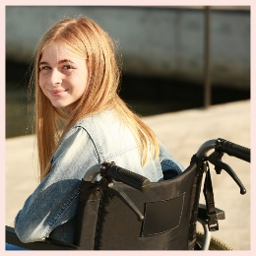
- Think about what schools teach and how they test pupils.
Is there anything that schools do that makes it harder for pupils who need extra help?
Like pupils
- with disabilities
- who speak a different language at home
- from homes that find it harder to pay bills and buy food
What can schools do to help these pupils?

Click or tap here to enter text.

Part 3. Secondary education – ages 11 to 16

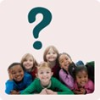
- Think about what schools teach and how they test pupils who are 11 to 16 years old.
Is there anything that schools do that makes it harder for pupils with differences?
Like pupils who have different bodies, religions, ages, skin colour or family lives.
The law calls these protected characteristics.
What can schools do to help these pupils?

Click or tap here to enter text.

Part 3. Secondary education – ages 11 to 16

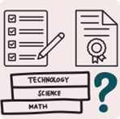

- Do English and maths help pupils get the skills they need for life and to carry on studying?
How can schools do this better?

Click or tap here to enter text.

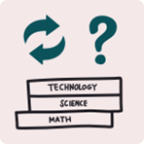
- Do schools help pupils learn enough different subjects?
Are there ways to do this better?

Click or tap here to enter text.

Part 3. Secondary education – ages 11 to 16

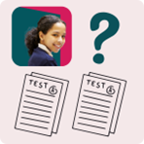
- Do pupils do the right number of GCSE exams and tests?
Are there any changes we should make?

Click or tap here to enter text.

- How can schools make sure GCSE exams and tests work well for all pupils?

Like pupils
- with disabilities
- who speak a different language
at home
- from homes that find it harder to
pay bills and buy food

Click or tap here to enter text.

Part 3. Secondary education – ages 11 to 16

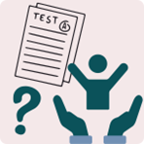
- Do school tests make a difference to pupils’ health?
What changes can schools make?

Click or tap here to enter text.

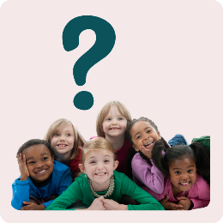
- Think about what schools teach and how they test pupils.
How much do schools help pupils learn about diversity and people who are different from them?
Do schools teach pupils to be kind and to respect other pupils?
Are there better ways to do this?

Click or tap here to enter text.

Part 3. Secondary education – ages 11 to 16


- A vocational course helps pupils get skills for work.
How much do vocational courses give pupils the skills they need to carry on studying?
How can schools make these courses better?

Click or tap here to enter text.

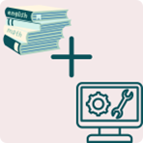
- About half of pupils do a vocational course at the same time as their GCSEs.
Is this a good idea?

Click or tap here to enter text.

Part 3. Secondary education – ages 11 to 16

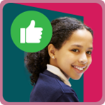
- Think about what schools teach and how they test their pupils when they are 11 to 14 years old.
This is in Year 3 to Year 6.
How can schools do more to help these pupils learn?

Click or tap here to enter text.

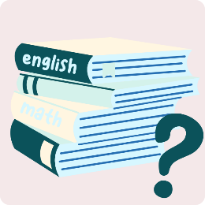
- Some pupils get low grades in primary school tests.
How can we help these pupils when they get to secondary school?

Click or tap here to enter text.

Part 3. Secondary education – ages 11 to 16

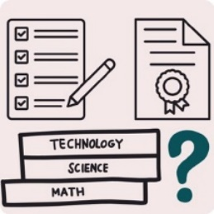
- Think about what schools teach and how they test their pupils.
How much do schools help pupils get the skills they need for life and to carry on studying?
How can schools do this better?

Click or tap here to enter text.

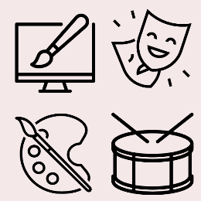
- Do schools teach enough arts, music and drama?
Are there ways to do this better?

Click or tap here to enter text.

Part 4. College and 16 to 19 education


- What works well for young people in college or 16 to 19 education?
Tell us what you think about:
- what they learn
- how they are tested
- how they can study towards certificates

Click or tap here to enter text.


- What does not work well for young people in college or 16 to 19 education?
Tell us what you think about
- what pupils learn
- how pupils are tested
- how pupils can study towards certificates

Click or tap here to enter text.

Part 4. College and 16 to 19 education

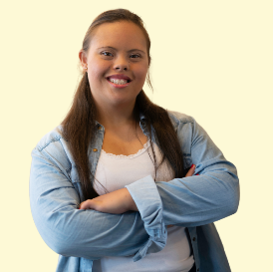
- Do colleges and course providers do anything that makes learning harder for young people who need extra help?

Like learners
- with disabilities
- who speak a different language
at home
- from homes that find it harder to
pay bills and buy food

Click or tap here to enter text.

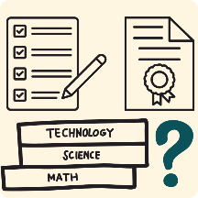
- What can help these young people learn?

You can tell us about:
- the subjects learners can choose from
- how learners are tested
- certificates to work towards

Click or tap here to enter text.

Part 4. College and 16 to 19 education

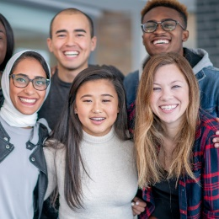
- Do colleges and course providers do anything that makes learning harder for young people with differences?
Like pupils who have different bodies, religions, ages, skin colour or family lives.
The law calls these protected characteristics.
What can we change to do this better?

Click or tap here to enter text.

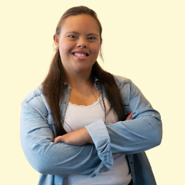
- How much do courses help learners understand about diversity and people who are different from them?
Do young people learn about being kind and respectful?
Are there better ways to do this?

Click or tap here to enter text.

Part 4. College and 16 to 19 education

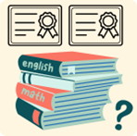
- How much do maths and English courses help pupils get the skills they need for life or to carry on learning?

What can we change to do this better?

Click or tap here to enter text.

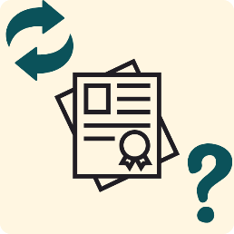
- Some learners do not get a certificate in English and maths by the age of 16.
How can we help these learners get the skills they need for work and life?

Click or tap here to enter text.

Part 4. College and 16 to 19 education

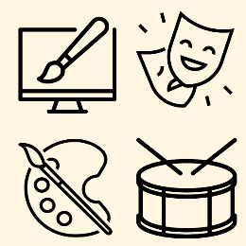
- Can young people choose enough arts subjects like music and drama?
What can we change to do this better?

Click or tap here to enter text.

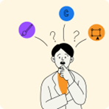
- How can we help young people to understand more about how different courses can help them get ready to
work or to carry on learning?

Click or tap here to enter text.

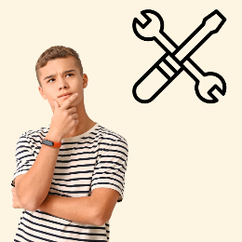
- How much help is there for young people who want to change course?

Click or tap here to enter text.

Part 4. College and 16 to 19 education



- Are there any skills or subjects that
all learners need to get ready for life
and work?

Click or tap here to enter text.


- How much do courses give learners
what they want and need?
How can courses be better?

Click or tap here to enter text.

Part 5. Anything else?

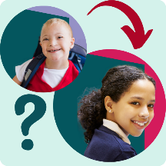

- How can we help children and young people when they move from one year to the next?

Click or tap here to enter text.

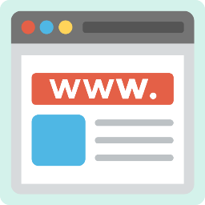
- How can we use technology to make education better for children and young people?
For example, websites, apps or technical devices.

Click or tap here to enter text.

Part 5. Anything else?

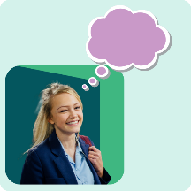

- Is there anything else you want to tell us?

Click or tap here to enter text.

Thank you

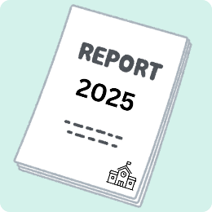
We will use what you tell us to write our report for the government in early 2025.

For news about the report, follow the Department for Education on X: @educationgovuk

And connect with us on Facebook: facebook.com/educationgovuk

Hard words and what they mean
A levels are Level 3 qualifications that some pupils do after GCSEs. Pupils doing A levels normally do 3 or more subjects in
2 years. After A levels, students can go to university, do further study, or work.
Confidential means we will not tell people your name or what
you say.
Curriculum This tells schools the subjects that pupils should learn and the standards they should reach. It makes sure all pupils learn the same thing. The government decides the curriculum for each subject and teachers decide the detail.
Diversity means a mix of different people. Like having a mix
of people who are disabled and non-disabled. Or who are from different cultures.
GCSEs are qualifications that pupils do in Years 10 and 11 of school. Pupils must study maths, English, science and other subjects. After GCSEs, pupils do further study like A levels or workplace training.
Government means the group of people who run the country.
Protected characteristic The law says it is wrong to treat someone badly or differently because of a protected characteristic. The 9 protected characteristics are: age, disability, gender, gender reassignment, race, religion and belief, marriage and civil partnership, pregnancy and maternity, and sexual orientation.
SATs stands for Standard Assessment Tests. They are English and maths tests that most pupils do in Year 6.
SEND is short for Special Educational Needs and Disabilities.
Vocational courses teach pupils practical and technical skills that are useful in a workplace. This helps learners go into jobs like health worker, plumber or chef.

Crown copyright 2024
This publication is licensed under the terms of the Open Government Licence v3.0, except where otherwise stated.

To view this licence, visit nationalarchives.gov.uk/doc/open-government-licence/version/3.

